Bug Report

Bug Report 1: OTP Email Not Received Despite Success Message
Bug ID: BUG-REG-001
Summary/Title: OTP email is not delivered to the user's inbox, but the UI displays "OTP sent Successfully".
Severity: High
Priority: High
Steps to Reproduce:
- Go to the application website.
- Click on the 'Signup' button.
- Click “Sign in with email”.
- Enter a valid email address (e.g., pantho97@gmail.com).
- Observe the popup message "OTP sent Successfully".
- Check the inbox (and spam folder) of the provided email address.
Expected Results: The OTP is received in the user's email and can be used to complete registration.
Actual Results: The OTP email is not found in the inbox or spam folder, preventing registration.
Environment/Browser Information: Windows 11, Chrome v131
Workarounds: Use "Sign in with Google" or "Sign in with GitHub" for registration.

Bug Report 2: No Validation for Incorrect 6-Digit OTP, Allows Invalid Login
Bug ID: BUG-REG-002
Summary/Title: System accepts any 6-digit code as a valid OTP and incorrectly logs the user in.
Severity: Critical
Priority: High
Steps to Reproduce:
- Complete steps 1-4 from BUG-REG-001 to reach the OTP verification screen.
- Enter any incorrect 6-digit number (e.g., 123456).
- Click the 'Submit' button.
Expected Results: A validation error message "Wrong OTP number" is displayed, and the user remains on the OTP verification screen.
Actual Results: The system accepts the incorrect OTP and navigates the user to the home page without a valid login session.
Environment/Browser Information: Windows 11, Chrome v131
Workarounds: None. This is a critical security and functionality flaw.

Bug Report 3: Twitter Registration Button on Main Signup Page is Unresponsive
Bug ID: BUG-REG-003
Summary/Title: The "Sign in with Twitter" button on the main registration page does not trigger the Twitter OAuth flow.
Severity: High
Priority: High
Steps to Reproduce:
- Go to the application website.
- Click on the 'Signup' button.
- On the main signup page, click the “Sign in with Twitter” button.
Expected Results: The user is redirected to Twitter to authenticate their account.
Actual Results: The page does not change; the button click has no effect. The user remains on the same page.
Environment/Browser Information: Windows 11, Chrome v131
Workarounds: Use the Twitter login option from the "Sign in with email" page, which was reported to work.

Bug Report 4: "Terms of Use" and "Privacy Policy" Links Are Not Clickable
Bug ID: BUG-CONTENT-001
Summary/Title: The "Terms of use" and "Privacy Policy" text on the login page are not hyperlinked.
Severity: Medium
Priority: Medium
Steps to Reproduce:
- Go to the application's login/signup page.
- Locate the "Terms of use" text at the bottom of the page.
- Attempt to click on it.
- Locate the "Privacy Policy" text.
- Attempt to click on it.
Expected Results: Each click opens the respective legal document page.
Actual Results: Clicking on the text has no effect. The elements are not interactive links.
Environment/Browser Information: Windows 11, Chrome v131
Screenshots/Videos: N/A (Noted during code inspection uses <span> instead of <a> tag)
Workarounds: None. Users cannot access the legal terms.

Bug Report 5: "Sign In" Link on Signup Page is Non-Functional
Bug ID: BUG-NAV-001
Summary/Title: The "Sign In" text/link on the signup page does not redirect users to the login page.
Severity: Medium
Priority: Medium
Steps to Reproduce:
- Go to the application website.
- Click on the 'Signup' button to navigate to the signup page.
- On the signup page, look for and click the "Sign In" text/link.
Expected Results: The user is navigated to the application's login page.
Actual Results: Nothing happens. The page does not change.
Environment/Browser Information: Windows 11, Chrome v131
Workarounds: Users must manually navigate back or modify the URL to access the login page.
Bug Report 6: Image Generation Fails with Generic Error Message
Bug ID: BUG-FEAT-001
Summary/Title: Image generator fails to create an image and displays "Failed to generate image. Please try again."
Severity: High
Priority: High
Steps to Reproduce:
- Log into the application.
- Navigate to the Image Generator section.
- Enter a valid, descriptive prompt (e.g., “Beautiful nature landscape...”).
- Select an image style.
- Click the 'Generate' button.
Expected Results: An image is generated and displayed based on the prompt.
Actual Results: A red error message appears: "Failed to generate image. Please try again." No image is generated.
Environment/Browser Information: Windows 11, Chrome v131
Workarounds: None. The core feature is broken.

Bug Report 7: Image Download Fails Due to CORS Policy Error
Bug ID: BUG-FEAT-002
Summary/Title: Clicking "Download" on a generated image fails with a CORS error message.
Severity: Medium
Priority: Low
Steps to Reproduce:
- Log into the application.
- Navigate to the Image Generator section.
- Locate any previously generated image.
- Click on the image to select it.
- Click the 'Download' button.
- Click 'OK' on the confirmation popup.
Expected Results: The image file is downloaded to the user's machine.
Actual Results: An error popup appears: "Failed to save image. The image might be blocked by CORS."
Environment/Browser Information: Windows 11, Chrome v131
Workarounds: Users can take a manual screenshot of the image as a temporary solution.

Bug Report 8: 'Forgot Password' Link of API Platform’s Login Page is Non-Functional
Bug ID: BUG-AUTH-004
Title: "Forgot Password?" link on platform login page is non-functional
Severity: Major
Priority: P2
Environment: Windows 11, Chrome v131
Steps to Reproduce:
- Navigate to https://platform.echogpt.live/.
- Click on the 'Forgot Password?' link.
Expected Result:
The user is redirected to a password recovery page to initiate a reset.
Actual Result:
The link does nothing or results in a "Page not found" error. Core account recovery functionality is missing.
Evidence: 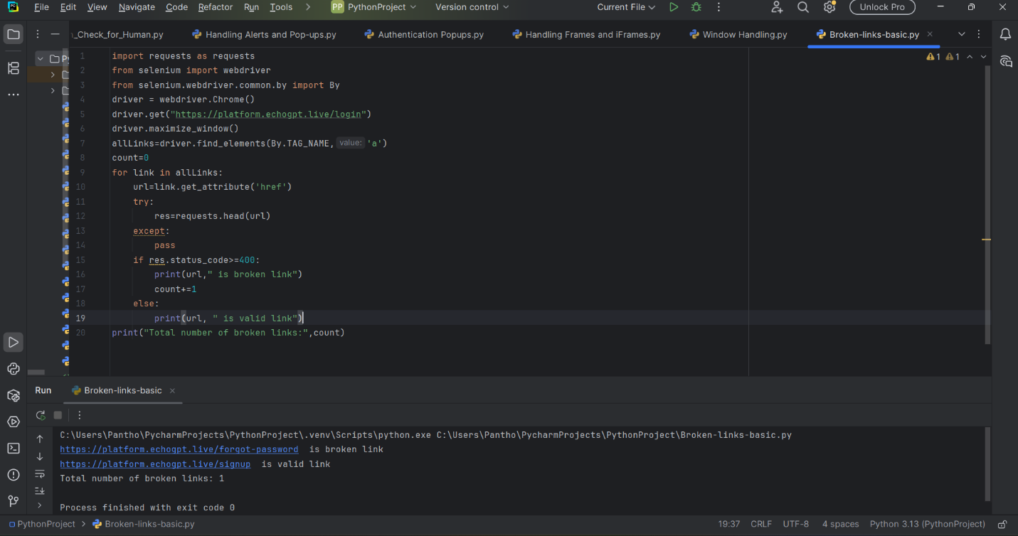
Selenium Code
import requests as requests
from selenium import webdriver
from selenium.webdriver.common.by import By
driver = webdriver.Chrome()
driver.get("http://www.deadlinkcity.com/")
driver.maximize_window()
allLinks=driver.find_elements(By.TAG_NAME,'a')
count=0
for link in allLinks:
url=link.get_attribute('href')
try:
res=requests.head(url)
except:
pass
if res.status_code>=400:
print(url," is broken link")
count+=1
else:
print(url, " is valid link")
print("Total number of broken links:",count)

